IV. Regression analysis

Pseudo code

1. Begin
2. Assign values into three arrays
   1. Assign the calories intake of all the members into calories
   2. Assign the weights of all the members into weight
   3. Assign the physical activities of all the members into phy
3. Create a function, linear_func, that returns slope * x + intercept
4. Create a function, linear_regression, to plot the graphs
   1. Calculate the slope and y-intercept of the linear regression
   2. Use linear_func to calculate the coresponding y values of the linear regression
   3. Plot the graph of y against x
   4. Plot the graph of the linear regression
   5. Display the graph
5. Main function
   1. Pass calories and weight to linear_regression to plot the graph of weight againt calories intakes and the linear regression
   2. Pass phy and weight to linear_regression to plot the graph of physical activities againt calories intakes and the linear regression
   3. Pass phy and calories to linear_regression to plot the graph of physical againt calories intakes and the linear regression
6. End

Flowchart

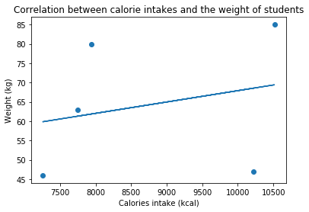

The graph shows positive correlation between the calorie intakes and the weight of students. As the calorie intakes of the students increase, the weights of the students also increase.

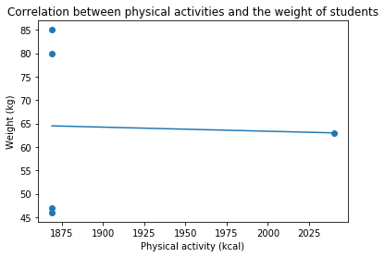

The slope of the linear regression graph is insignificant. There is no correlation between the physical activities and the weights of the students.

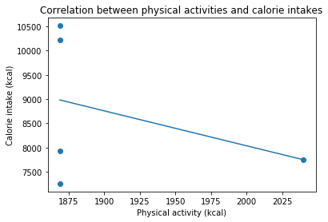

As the physical activity increases, the y value of the linear regression graph decreases. Hence, the graph shows negative correlation between the physical activities and the calorie intakes of the students.